Pattern Generator and Switch Case
26-10-25
Aim – Implement a program to print patterns and a program to display 4 digit number in words using switch case statement
Theory –
For Loop - The for loop executes a block of code repeatedly for a specified number of times, simplifying iteration and making repetitive tasks easier and faster.
Switch Case - The switch case allows multi-way branching based on variable values, making code cleaner, efficient, and easier to read than multiple if-else statements.
A1.
#include <stdio.h>
void main() {
int n, i, j, space;
printf("Enter number of rows for the upper half: ");
scanf("%d", &n);
for (i = 1; i <= n; i++) {
for (space = i; space < n; space++){
printf(" ");
}for (j = 1; j <= i; j++){
printf("* ");
}
printf("\n");
}
printf("\n");
for (i = n - 1; i >= 1; i--) {
for (space = n; space > i; space--){
printf(" ");
}for (j = 1; j <= i; j++){
printf("* ");
}
printf("\n");
}
}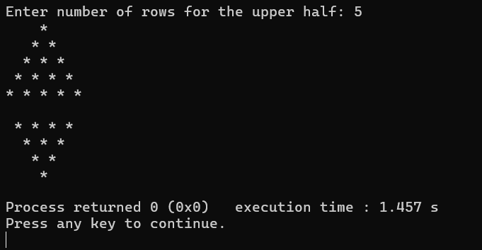
A2.
#include <stdio.h>
void main() {
int n, i, j, space;
printf("Enter the number of rows for the upper half of diamond: ");
scanf("%d", &n);
for (i = 1; i <= n; i++) {
for (space = i; space < n; space++){
printf(" ");
}
for (j = 1; j <= (2 * i - 1); j++){
printf("*");
}
printf("\n");
}
for (i = n - 1; i >= 1; i--) {
for (space = n; space > i; space--){
printf(" ");
}
for (j = 1; j <= (2 * i - 1); j++) {
printf("*");
}
printf("\n");
}
}
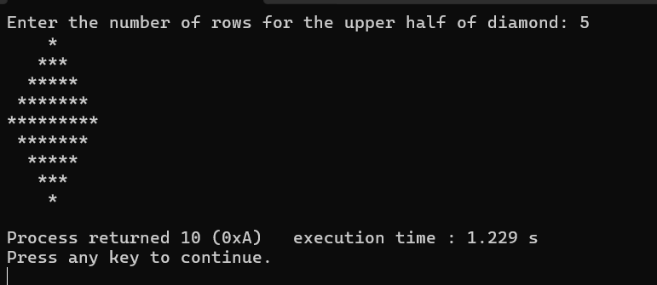
A3.
#include <stdio.h>

void main() {
int num, digit1, digit2, digit3, digit4;

printf("Enter a 4-digit number: ");
scanf("%d", &num);

if (num < 1000 || num > 9999) {
printf("Please enter a valid 4-digit number.\n");
} else {
digit1 = num / 1000;
digit2 = (num / 100) % 10;
digit3 = (num / 10) % 10;
digit4 = num % 10;

printf("In words: ");

switch (digit1) {
case 1: printf("One"); break;
case 2: printf("Two"); break;
case 3: printf("Three"); break;
case 4: printf("Four"); break;
case 5: printf("Five"); break;
case 6: printf("Six"); break;
case 7: printf("Seven"); break;
case 8: printf("Eight"); break;
case 9: printf("Nine"); break;
}
printf(" Thousand ");

switch (digit2) {
case 0: break;
case 1: printf("One"); break;
case 2: printf("Two"); break;
case 3: printf("Three"); break;
case 4: printf("Four"); break;
case 5: printf("Five"); break;
case 6: printf("Six"); break;
case 7: printf("Seven"); break;
case 8: printf("Eight"); break;
case 9: printf("Nine"); break;
}
printf(" Hundred ");
if (digit3 == 1) {
switch (digit4) {
case 0: printf("Ten"); break;
case 1: printf("Eleven"); break;
case 2: printf("Twelve"); break;
case 3: printf("Thirteen"); break;
case 4: printf("Fourteen"); break;
case 5: printf("Fifteen"); break;
case 6: printf("Sixteen"); break;
case 7: printf("Seventeen"); break;
case 8: printf("Eighteen"); break;
case 9: printf("Nineteen"); break;
}
} else {
switch (digit3) {
case 2: printf("Twenty "); break;
case 3: printf("Thirty "); break;
case 4: printf("Forty "); break;
case 5: printf("Fifty "); break;
case 6: printf("Sixty "); break;
case 7: printf("Seventy "); break;
case 8: printf("Eighty "); break;
case 9: printf("Ninety "); break;
}

switch (digit4) {
case 1: printf("One"); break;
case 2: printf("Two"); break;
case 3: printf("Three"); break;
case 4: printf("Four"); break;
case 5: printf("Five"); break;
case 6: printf("Six"); break;
case 7: printf("Seven"); break;
case 8: printf("Eight"); break;
case 9: printf("Nine"); break;
}
}
}
printf("\n");
}

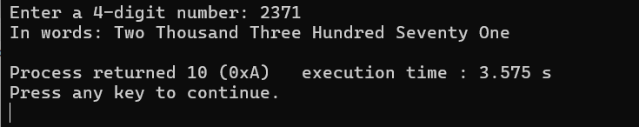
Conclusion
In this assignment, I experimented with creating patterns using loops and converting four-digit numbers into words with the switch-case statement. It gave me a clearer understanding of how loops and decision-making work in C, boosting my programming confidence and problem-solving skills.

